Full Title - The Title Should Be Bold and Centred
(Arial 15)

Presenting Author (Arial 11)
Co-Authors (Arial 10)
Organization, Address, City, Country (Arial 10)
Contact@E-mail (Arial 10)

Abstract (Arial 11)

ONE page abstract format: including figures and references.
Do not change the font sizes or line spacing to squeeze more text into a limited number of pages.
Please follow the model below.
Single-spaced and a single paragraph
Page margins are 1,10 cm top and down; 1,90 cm left and right.
Greek letters, sub- and superscripts should be formatted as such.

REFERENCES

- Authors, Journal, Issue (Year) page (Arial 11) Indicate references with sequential numbers within [square brackets].
- Authors, Journal, Issue (Year) page
- Authors, Journal, Issue (Year) page
- Authors, Journal, Issue (Year) page

FIGURES



Figure 1: Insert caption to place caption below figure (Arial 10)

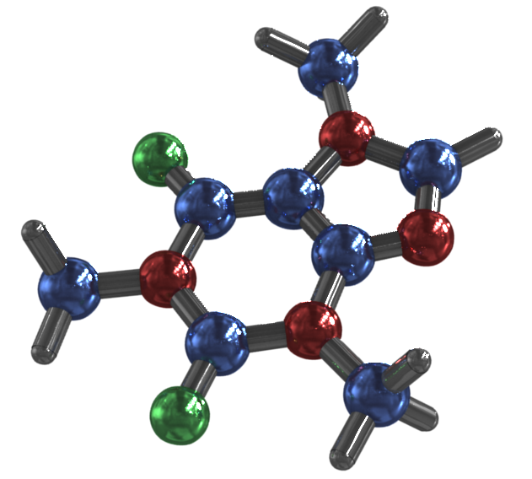

Figure 2: Insert caption to place caption below figure (Arial 10)

